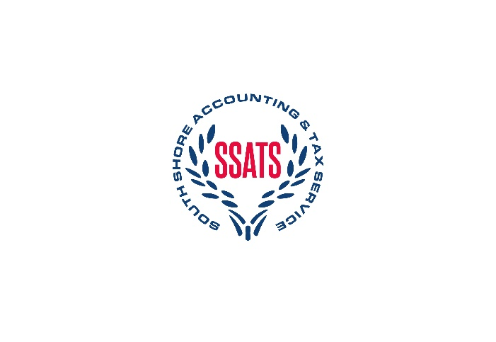
SSATS Tax Appointment Checklist

- A copy of your prior year tax return
- Income statements (W-2’s, 1099’s, gambling winnings, retirement, broker statements, interest and dividend income, misc income)
- IRA Contributions
- IRS or state tax notices
- Itemized deductions (Mortgage interest, real estate taxes, excise taxes, gambling losses, donations)
- Education (Student loan interest, tuition fees and expenses)
- Health Insurance Statements
- Health Statements (1095-A, 5498SA, 1099QA)
- New client form (Located under the resources tab)
- Retirement distributions
- Social Security benefits

